Template to use – Test Cases
Test Case Identifier |  |  | <Test Case No>
Test Case |  |  | <Name of the Test Case>
Test Designed by |  |  | <Name of the person who designed>
Test Designed Date |  |  | <Date of Test case design>
Test Executed by |  |  | <Name of the person who executed>
Test Executed Date |  |  | <Date of Test case Executed>
Description |  |  | <Brief Description of the Test Case>
Pre-Condition |  |  | <If there is a pre-condition affiliated state it>
Dependencies |  |  | <If any Dependencies are available state it>
Test Case # | Sequence # | Test Case Description |  | Test Data / Input Value(s) | Expected Result | Status  (Pass/Fail)
01 | 1.1
Actual Result - <Status>

Screen Shot

Examples
Table 4.1 – Test Case – Log in
Test Case Identifier |  |  | 01
Test Case |  |  | Login
Test Designed by |  |  | Dhishan Dhammearatchi
Test Designed Date |  |  | 09th May 2021
Test Executed by |  |  | Dhishan Dhammearatchi
Test Executed Date |  |  | 10th September 2021
Description |  |  | User enters the email and password. Selects whether to login as a teacher or a student and clocks on the login button. The user should be directed to the homepage if the valid login details are entered or it should display a warning if the login details are incorrect
Pre-Condition |  |  | User should be registered
Dependencies |  |  | An operating computer with an operating web browser should be Installed
Test Case # | Sequence # | Test Case Description |  | Test Data / Input Value(s) | Expected Result | Status  (Pass/Fail)
01 | 1.1 | When username and password is empty |  | Username = “”  Password = “” | Error Message “Please enter a valid username or password” | Pass
 | 1.2 | When username is empty |  | Username = “”  Password”****” | Error message “Please enter a valid user name” | Pass
 | 1.3 | When password is empty |  | Username = “S001”  Password = “” | Error message “Please enter the password” | Pass
 | 1.4 | When username and password wrong |  | Username = “a123”  Password = “123” | Error message “Please enter the correct username and password” | Pass
 | 1.5 | When login is successful |  | Username = “S001”  Password = “****” | Validated and re-directed to the home page | Pass
Actual Result – Pass

Screen Shot
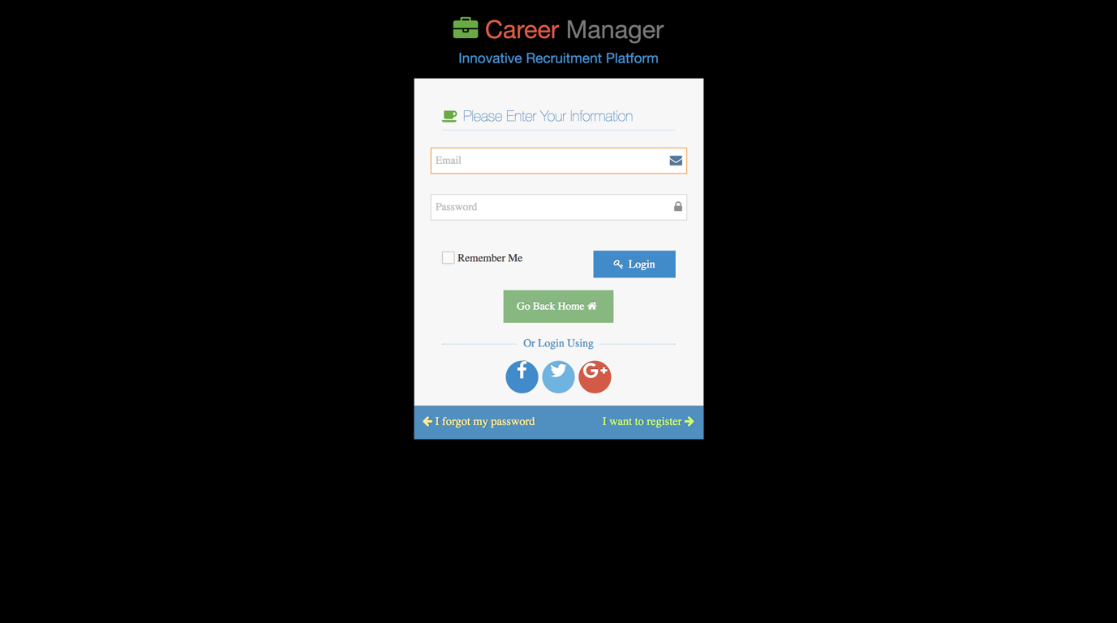

Table 4.2 – Test Case – Request for Registration
Test Case Identifier |  |  | 02
Test Case |  |  | Request for Registration
Test Designed by |  |  | ABC
Test Designed Date |  |  | DATE
Test Executed by |  |  | ABC
Test Executed Date |  |  | DATE
Description |  |  | User enters the details such as name, school, class, email address, password, index number and the tole and click on the request button. If all the details are entered and the password matches the confirm password a message should be displayed indicating that the process is successful. Error should be should if any of the details are missing or the passwords do not match
Pre-Condition |  |  | Participant should be able to visit the site
Dependencies |  |  | A functioning computer and a web browser is needed
Test Case # | Sequence # | Test Case Description |  | Test Data / Input Value(s) | Expected Result | Status  (Pass/Fail)
02 | 2.1 | When all the filed are empty |  | Name = “”  School = “”  Class = “”  Email = “”  Password = “”  Confirm password = “”  School = “”  Index No = “”  Role = “” | Warning message for each field | Pass
 | 2.2 | When full name filed is empty |  | Name = “”  School = “XXX”  Class = “XX”  Email = “XXX”  Password = “XXX”  Confirm password = “XXX”  School = “XXX”  Index No = “XXX”  Role = “XX” | Error message “” Please enter the name | Pass
 | 2.3 | When school filed is empty |  | Name = “XXX”  School = “”  Class = “XX”  Email = “XXX”  Password = “XXX”  Confirm password = “XXX”  School = “XXX”  Index No = “XXX”  Role = “XX” | Error message “” Please enter the School | Pass
 | 2.4 | When the class filed is empty |  | Name = “XXX”  School = “XXX”  Class = “”  Email = “XXX”  Password = “XXX”  Confirm password = “XXX”  School = “XXX”  Index No = “XXX”  Role = “XX” | Error message “Please enter the class” | Pass
 | 2.5 | When email filed is empty |  | Name = “XXX”  School = “XXX”  Class = “XX”  Email = “”  Password = “XXX”  Confirm password = “XXX”  School = “XXX”  Index No = “XXX”  Role = “XX” | Error message “Please enter the email” | Pass
 | 2.6 | When password filed is empty |  | Name = “XXX”  School = “XXX”  Class = “XX”  Email = “XXX”  Password = “”  Confirm password = “XXX”  School = “XXX”  Index No = “XXX”  Role = “XX” | Error message “Please enter the password” | Pass
 | 2.7 | When confirm password filed is empty |  | Name = “XXX”  School = “XXX”  Class = “XX”  Email = “XXX”  Password = “XXX”  Confirm password = “”  School = “XXX”  Index No = “XXX”  Role = “XX” | Error message “Please enter the confirm password” | Pass
 | 2.8 | When School filed is empty |  | Name = “XXX”  School = “XXX”  Class = “XX”  Email = “XXX”  Password = “XXX”  Confirm password = “XXX”  School = “”  Index No = “XXX”  Role = “XX” | Error message “Please enter the school information” | Pass
 | 2.9 | When the index number filed is empty |  | Name = “XXX”  School = “XXX”  Class = “XX”  Email = “XXX”  Password = “XXX”  Confirm password = “XXX”  School = “XXX”  Index No = “”  Role = “XX” | Error message “Please enter the Index No” | Pass
 | 2.10 | When role filed is empty |  | Name = “XXX”  School = “XXX”  Class = “XX”  Email = “XXX”  Password = “XXX”  Confirm password = “XXX”  School = “XXX”  Index No = “”  Role = “” | Error message “Please enter the role” | Pass
 | 2.11 | When all the fields are correct |  | Name = “XXX”  School = “XXX”  Class = “XX”  Email = “XXX”  Password = “XXX”  Confirm password = “XXX”  School = “XXX”  Index No = “”  Role = “XXX” | Message appearing “Successfully Registered” | Pass
Actual Result - Pass

Screen Shot
<SS>

